Business Process: Collective Billing

Contact
Business Process Owner | Billing Solutions
Subject Matter Expert(s) | Sr CSR, Revenue Analyst, Supervisor
Key Contact | Maya Duarte
Key Role | Sr. CSR: manage new collective billing request Revenue Analyst: training of collective bill procedure Supervisor: manage assignments
Date Created | 02/26/2026

Business Process Overview
Collective or Summary Billing allows SMUD to provide Commercial customers with a single Summary invoice instead of multiple invoices for each of their individual accounts.

If a customer requests Collective Billing, the Contact Center CSR will email customer information to the SMUD Billing Inbox (Billing@smud.org). The Collective Billing CSR will email a packet to the customer with an information sheet, Collective Billing Agreement, Enrollment form and return envelope. Educate the customer to continue paying bills until notification of completed enrollment.

When the packet is received by Billing for a customer eligible for Collective Billing, a “Collective aka Parent” account is established and "Detail aka Child" accounts are assigned. Detail accounts can be added or removed from Collective Billing by the Collective Billing CSR in Billing Operations.

Business Process Assumptions, Prerequisites, Dependencies
(Assumptions pertaining to the business process)
People | - Billing CSR’s will be responsible for approving collective bill request, setting up new accounts, make changes and/or cancel Collective Billing
Process | - Customers will receive a consolidated statement each month  - Customers will send only one payment for consolidate account for full combined balance due
Technology | - SAP is used to set up Collective Billing accounts  - Kubra is vendor who creates invoices

Process Flowchart
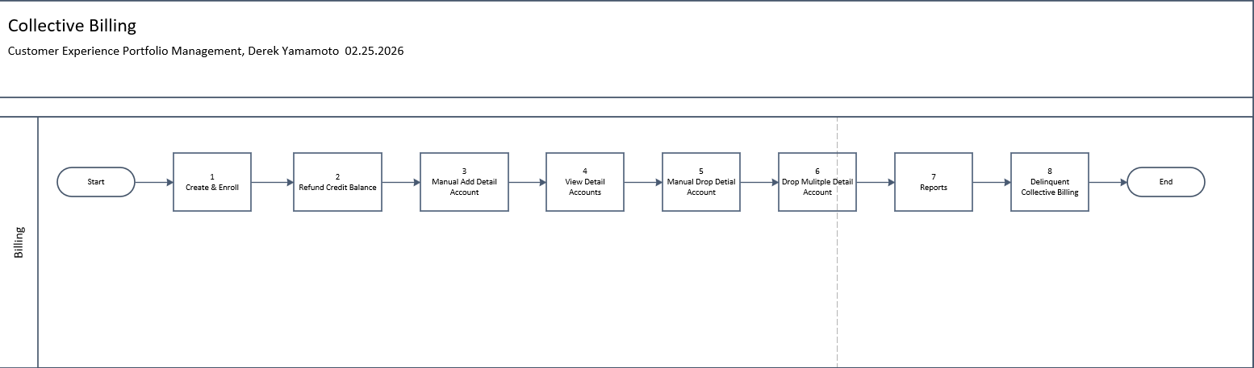

Task Description
Id | Task Description | Procedure
1 | Create & Enroll | Determine eligibility, pre-enrollment packets, create collective account in SAP. Link below with detail process flow
2 | Refund Credit Balance | Collective accounts with credit balance and using SAP transaction FPL9 to initiate refund. Link below with detail process flow
3 | Manual Add Detail Account | Delete and create open bill orders. Link below with detail process flow
4 | View Detail Accounts | CSR access to view collective account using account display in SAP. Link below with detail process flow
5 | Manual Drop Detail Account | CSR access to manual drop info through transaction ZCSBH in SAP. Link below with detail process flow
6 | Drop Multiple Detail Account | CSR process to drop customer account from collective billing. Link below with detail process flow
7 | Reports | All reports related to collective billing. Link below with detail process flow
8 | Delinquent | CSR process to manage delinquent collective bill accounts. Link below with detail process flow
 | Additional Flow Charts | ID’s 1-8 links to detailed process map procedures  Collective Billing.vsdx

Business Rules
Id | Event Name | Business Rules
 |  | New customers must sign a new request for Collective Billing
 |  | Five or more commercial accounts are required for enrollment and can include Residential or NL accounts that will stay in the customer’s name
 |  | No more than two late payments in the last 12 months
 |  | Customers who have filed Bankruptcy are ineligible for Collective Billing
 |  | Accounts must have a zero balance at the time of enrollment & no credit balance
 |  | Accounts must be in owner’s name with continuous service (no move in/move out activity)
 |  | Only house meters are eligible for ISA customers
 |  | No more than 50 detail accounts per Collective account
 |  | The billing cycle for the collective account must be minimum three cycles greater than the highest cycle of all detailed accounts linked to it
 |  | If detail accounts span more than ten billing cycles, two or more Collective Accounts may need to be established
 |  | Collective Accounts are currently unable to participate in paperless billing
 |  | Collective Accounts are unable to pay bills on My Account using Collective Account number
 |  | Collective Accounts are unable to pay through the IVR unless they go through a CSR to create a Kubra token for the collective account
 |  | Detail accounts with a descriptive address of more than 50 characters will need to be updated to 50 characters or less. Otherwise, an error will be generated, and Kubra will not be able to bill the collective file for that cycle
 |  | You cannot process any Pull Bill operations for Contract Accounts associated with Collective Billing. See related documents for additional information.

Event | Legal Requirements, Rules, and Regulations  Legal documents/ procedures/ requirements to be fulfilled before/at the specified event.
Id | Event | Legal Requirements, Rules and/or Regulations
 |  | Collective Billing.pdf

Departments impacted by process change (Required)

Department | Type of Change(s) | Action Required
Contact Center | S4Hana | TBD
Billing | S4Hana | TBD
Customer & Community Services (SAA’s) | S4Hana | TBD
Credit | S4Hana | TBD

Supporting Documentation
(Any subsequent documentation in support of this business process (i.e. business requirements, technical specs, etc.) shall be summarized in the following table.)
Document Type | Link
Process and Procedure Document | Collective Billing.pdf

Business Blueprint Amendments

Any subsequent changes to this business process blueprint after the official document approval shall be summarized in the following table. This document must be reprinted and signed by the authorized representatives.
Version | Author | Description of Change | Approval (Name/Sign) | Date
V1 | Derek Yamamoto | S4Hana Migration

